Mangakino Stream
Pureora FP
From the western Taupo highway, enter Pureora FP to river bridge (take out) Hike up on ex forestry road then bush bash into stream. Apparently a tubing trip, deep pools with some rapids. Often inescapable in upper reaches. TL wall usually vertical, TR frequently available. Take out at river bridge
Park car here
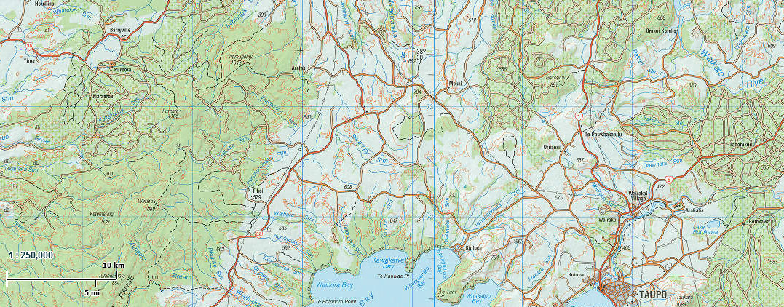
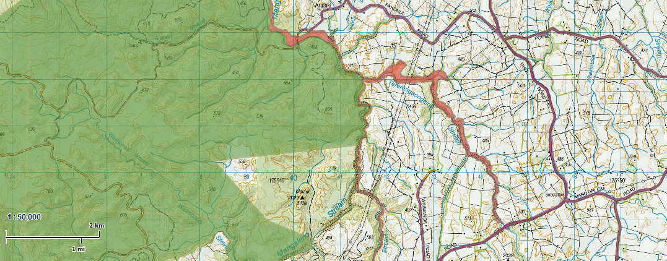
Green and Purple overlay shows public access land (www.wams.org.nz)
Park car here
Put in here

